The Plant Doctor 

**Group #7:**

**Project Manager/Lead Hardware Developer:**

Rachel Vears - [rachlevears@gmail.com](mailto:rachelvears@gmail.com)

**Lead Software Developer**

Jason Schilling - [jschilling2013@fau.edu](mailto:jschilling2013@fau.edu)

**Advisor:**

Dr. Hari Kalva - [hkalva@fau.edu](mailto:hkalva@fau.edu)

**Florida Atlantic University**

**Department of Computer Engineering and Computer Science**

**Fall 2019**

**Project Summary:**

Houseplants can be difficult to grow without extensive research regarding each plant’s specific environmental needs. The purpose of this project is to provide a compact, household device that analyzes a plant’s health using a combination of environmental measurements and visual machine learning.

**Table of Contents**

Contents

1 Introduction. 2

1.1 Problem Description. 2

1.2 Significance of the Problem. 2

1.3 Overview of the Solution. 3

1.4 Goals and objectives. 3

1.5 Related Research. 3-8

2 System Design. 8

2.1 Project Requirements. 8-9

2.2 Project Requirements Not Met 9-10

2.3 Project Requirements Added. 10

2.4 System Diagram. 11-21

2.5 State Diagram. 21-23

3 System Implementation. 24

3.1 Hardware. 24-31

3.2 Software. 31-35

3.3 User Interface. 36

3.4 Data Communications. 37

4 Testing and Performance Evaluation. 38-39

4.1 Performance Assessment 40-41

5 Budget 41-42

6 Project Management and Workload Distribution. 43-44

7 References. 44-48

# 

# **1. Introduction**

## **1.1** **Problem Description**

There are currently no great market solutions for determining a plant’s health and providing aid to plant owners on how to improve their plant’s growing conditions. The market solutions currently available are geared towards measuring water content and do not encompass the specific environmental conditions that are either beneficial or detrimental to different types of plants. Our ultimate goal is to allow users to easily be able to take a picture of the plant and receive measurements from the device for a streamlined plant health diagnosis.

## **1.2** **Significance of the Problem**

It can be difficult for the average person to put forth the necessary effort into researching the specific care needs of each house plant that they have in their home, especially those houseplants that need special attention or require very specific environmental conditions to remain healthy. Furthermore, when the variety of different types of houseplants increases, it can become overwhelming to keep track of each plant’s specific care needs.

This problem is particularly applicable to young children who would need a more interactive and visual approach to learning about and taking care of their plants. Likewise, older people who might have a more difficult time keeping track of their plant’s requirements would benefit from a device that could tell them exactly what their plant is either lacking or receiving too much of. Many consumer dollars would be saved by preventing plant owners from having to rebuy plants that die too quickly due to unintentional neglect. The current market solutions for monitoring plant environment conditions are either too complicated to implement for the casual houseplant enthusiast, or they do not provide enough detailed feedback to be very useful for more difficult plants. Users might either feel overwhelmed by a system that provides too much information, or discouraged when their current methods of measuring plant growing conditions are not detailed enough to pinpoint the problem. Our ultimate goal is to allow users to simply take a picture of a plant and receive a diagnosis of the plant’s environmental conditions and overall health.

## **1.3 Overview of the Solution**

The Plant Doctor “diagnoses” a plant’s health and environmental conditions and then tells the user exactly what the plant needs to be the healthiest that it can be. The complexity of maintaining plants is simplified down to taking a picture of the plant and receiving suggestions on its care. The user simply needs to place the environment sensor module in the plant’s soil, log in to the Plant Doctor smartphone application, and take a picture of the plant. Taking a picture of the plant alerts the module to start collecting environment data such as soil moisture, humidity levels, light intensity, and room temperature. It then transmits this data to the application. Simultaneously, the image of the plant that was just taken is sent to the machine learning module, where it will determine the plant’s soil pH value based on visual markers. After these two processes are complete, the final information is displayed to the user through an easy to understand user interface. The interface will tell the user exactly what the current conditions are and if each condition is ideal or not for the specific type of plant it is diagnosing.

## **1.4** **Goals and objectives**

The goal of this project is to develop an accurate plant health diagnosis tool that is able to identify whether the current growing conditions for a houseplant are ideal or not. If not, the device will be able to provide feedback to the user on exactly what environmental conditions need to be changed and by how much. This goal is to be able to diagnose almost any houseplant and provide feedback tailored to each specific plant species. The main objectives of the project are as follows:

1. Build plant health monitor prototype to immediately begin collecting sensor data for deep learning data sets. (Rachel Vears)
2. Design and implement a single device that houses multiple sensors and components to retrieve plant health data and send it to the application (Rachel Vears).
3. Configure and train a deep learning network that can successfully predict plant health metrics using a single photo (Jason Schilling).
4. Design and implement a phone application that retrieves photos of the plant taken by the user and uses a deep learning network to predict the plant health metrics (Jason Schilling).

## **1.5** **Related Research**

There are currently not many solutions presented on the market for accurate houseplant health monitors. The one product available, the Vistefly Flowers Care Smart Sensor, measures moisture, sunlight, temperature, and “fertility,” but doesn’t provide feedback based on your plant’s specific needs. Additionally, the claim that the sensor measures soil fertility is unfounded, as the device is not actually able to deliver that metric. This product solely relies on the data provided by the sensors, while our proposed device would ultimately use a combination of visual recognition and sensor measurements to determine plant health and provide a diagnosis of which environmental conditions need adjusting for optimum plant growth.

Some patents were found with similar systems, but none are targeted at the same demographic that our system is targeting.

**Patent Number**: CA2752594C

**Title**: Networked Intelligent Plant Growth System

**Inventor**: Xinxin Shan

**Assignee**: Xinxin Shan

**Date Filed**: 09/09/2011

**Date Granted**: 12/04/2018

**Number of Claims**: 64

**Summary**: This patent is for the Networked Intelligent Plant Growth System, which is a nexus of intelligent terminals that measure light intensity, light color, CO2 levels, humidity, leaf color, fertilization, and room temperature. The terminals are able to adjust those metrics based on a “growing formula” for each type of plant. To improve the growing formulas, each terminal is connected to a data exchange and communication center via a network that allows them to share and receive growing information collected by all the terminals being used, which are also connected to a network. Based on the data being collected by all the terminals, the system is able to learn the best growing formula for all the different types of plants. This allows for the system to better monitor the health of the plant and adjust the growing conditions by learning from the “crowdsourced” metrics.

**Relevance**: This patent is very similar to what we are planning to do for our project as they both measure light intensity, humidity, room temperature, leaf color, and they use the data being collected by a network of terminals to intelligently determine the best conditions for each type of plant. The data being collected and stored in the data exchange and communication center is accessible to the public via internet access, and is the center in which the growing formulas are developed. This is very similar to our project in that we plan to implement an application for the user to monitor the data being collected by our plant monitor system, and are able to view the “ideal” conditions for the plant. These ideal conditions for the plants would be gained through machine learning and analytics of the data being collected by all the implementations of the plant monitor that are connected to the app. Some of the major differences are that the patent aims to use a complex LED lighting system to provide specific colors and intensities of light based on the plant’s individual requirements. It is also scalable, and the inventor claims it would be able to function in a large scale environment such as an entire greenhouse, or an “underground haven.” Our project is aimed towards individual house plants and would most likely not scale to service entire buildings.

**Patent** **Number**: US20090025287A1

**Title**: Plant Growing System

**Inventor**: Yu Mei Lee

**Assignee**: Yu Mei Lee

**Date** **Filed**: 06/25/2007

**Date** **Granted**: 01/29/2009

**Number** **of** **Claims**: 20

**Summary**: This patent is for a Plant Growing System which is essentially a self-monitoring, autonomous greenhouse. The system is an enclosure designed to create ideal plant growing conditions, and is comprised of several control modules in charge of running the system’s sensors. The metrics that the system is able to collect are: light, humidity, air temperature, nutrient levels, and water level. The system would be able to control those metrics via their respective control modules, and is able to relay those measurements to the user through an audio and graphical user interface module. The system is described to be able to adjust humidity, temperature, light, and nutrient levels autonomously with little interference needed from the user. The entire system is powered by solar energy. The inventor describes the patent as “an all in one growing system,” designed to make growing a plant effortless due to its self sufficiency.

**Relevance**: This patent is relevant to our project because it measures the same metrics that we aim to measure with our plant monitor. They both measure light, humidity, air temperature, and certain nutrient levels in the soil. However they are dissimilar in that the aforementioned plant growing system patent is a self-contained, smart greenhouse that is capable of adjusting the measured conditions by itself; whereas our project is a monitor designed to measure plant health and report to the user, and does not possess the capability to alter the growing conditions autonomously. Moreover, our project will be able to use machine learning to analyse photographs of the plant in tandem with sensor measurements to more accurately judge plant health, and the patent does not mention a machine learning aspect of the system. Additionally, the inventor does not go over how the system judges what conditions are ideal for varying types of plants. Our system would be designed to learn and adjust ideal plant conditions for individual species of plants by collecting and analysing the user data over time.

**Patent** **Number**: KR101830056B1

**Title**: Blight diagnosis method and system

**Inventor(s)**: 김태완, 이훈형, 김지수, 김세한, 박현, 은지숙

**Assignee**:한양대학교 에리카산학협력단

**Date** **filed**: 2017-07-05

**Date** **granted**: 2018-02-19

**Number** **of** **claims**: 4 (really only 1)

**Summary**: This patent is for a device that can diagnose blight in plants using an image of an affected plant. The image is obtained by using a smartphone to take a picture, and diagnostic information is subsequently presented on the smartphone. This patent uses deep-learning techniques to successfully diagnose the diseases. The submitted photo can either match with a pre-existing disease in the database or have the user begin a new diagnosis process for this “new” disease. All photos are uploaded to the existing database with their diagnosis data to reinforce future predictions. The inventors claim this technology is important in close-quarter smart farms because the disease can spread quickly. They also say the best way to diagnose plant disease is by visual inspection by an expert, so this technology brings the expert to the farm.

**Relevance**: This patent covers technology very similar to what we want to implement in our project. Both projects aim to diagnose the health status of plants by using an image of the plant, but our project examines the general health of the plant while this patent’s goal is to examine specific disease affecting the plant. The patent also says it provides diagnostic information after diagnosis and uploads the image to the existing database to reinforce the implement learning techniques, which are both goals of our system as well. It is unclear how the inventor’s built their original dataset of diseases and plant images, but we will be using sensors in conjunction with the images to do this, which the inventors made no mention of. The inventors stated that images in different conditions make it difficult to properly diagnose the plant diseases. This has already been identified as a concern for our project as well, so seeing others have this issue means we need to apply extra effort in resolving this issue.

**Patent** **Number**: AU2014101143A4

**Title**: Plant profile game system

**Inventor(s)**: Stephen Ecob, Ian Oliver

**Assignee**: Oliver, Ian James

**Date** **filed**: 2014-09-13

**Date** **granted**: 2014-10-23

**Number** **of** **claims**: 4

**Summary**: This patent is for a system which monitors the environment of a plant and alerts users when the plant needs attention and rewards users when they successfully care for the plant. This system uses several sensors, including sensors for air temperature, soil temperature, soil moisture, humidity, sunlight, and soil acidity. The system compares the sensor measurements with a database of ideal measurements and recommends actions based on the comparison. The system also tracks the lifecycle of the plant and changes its recommendations based on that. The inventors claim that this system helps young children get engaged with gardening and can help adults by doing the tracking itself for when the plant needs attention.

**Relevance**: This system is similar to the system we want to implement, as both utilize sensor data to track the plant’s environment and compare it to an ideal environment to recommend resolution actions to the users. Our system does not reward users for caring for their plant, and while there are fewer sensors implemented in our system we utilize image classification techniques which the patent does not mention. However, some of the sensors mentioned by the patent could be implemented in our system if cheap enough, and reminders could be set up for the user to enhance the purpose of the system, which is to monitor and improve a plant’s health.

# **2.** **System Design**

## **2.1** **Project Requirements**

The following section breaks down the functionality, usability, and safety requirements to be implemented in the house plant monitor. These project requirements provide an overview of the services that the final product will be able to provide to the user, how the user is intended to interact with the device, and the safety precautions to be implemented in the device.

These project requirements were gathered through research of the current solutions on the market, what they implement and what they lack. Research into patents that are currently not on the market, as shown in the literature survey in the previous section.

Functional Requirements

F.1. The system shall measure the moisture content of potting soil.

F.2. The system shall measure the level of humidity in the air.

F.3. The system shall measure the pH of the potting soil.

F.4. The system shall measure the amount of sunlight reaching the plant.

F.5. The system shall measure the ambient air temperature surrounding the plant.

F.6. The user application shall use visual recognition to supplement plant health diagnosis.

F.7. The system shall transmit sensor metrics through bluetooth to the application, which sends the data to the system database via a server.

F.8. The metrics measured by the device shall train the application in visual recognition plant diagnoses.

F.9. The system shall compare retrieved plant metrics to standardized plant requirements in the system’s database.

Usability Requirements:

U.1 The system shall communicate with a smartphone app to display measured metrics.

U.2 The system shall be able to operate without recharging for at least 36 hours.

U.3 The system shall be lightweight, compact, and portable.

U.4 The system shall display the retrieved data in a user-friendly format.

U.5 The system shall incorporate user login credentials to access the app.

Safety Requirements:

S.1 The system packaging shall be water resistant.

S.2 The system packaging shall be shatter resistant.

S.3 The system application shall encrypt user login information.

## **2.2** **Project Requirements Not Met**

The following functional requirements were not met due to time constraints and a need to focus on developing the custom machine learning model:

F.7. The system shall transmit sensor metrics through bluetooth to the application, which sends the data to the system database via a server.

F.9. The system shall compare retrieved plant metrics to standardized plant requirements in the system’s database.

It is important to note that the functional requirement F.7 was only partially unmet. The system fully transmists sensor metrics through bluetooth to the application, however it is unmet in that it does not send the data to the system database via server. As previously mentioned, the implementation of the system database was removed from the final project due to time constraints and the difficulty in implementing a custom machine learning model. This applies to functional requirement F.9 as well.

Furthermore, the safety requirement “S.1. The system packaging shall be water resistant.” was unmet due to difficulties with the 3D printed enclosure. There were several instances where the 3D printer malfunctioned, which delayed the case being printed by at least a week. Thus, by the time the 3D case was received, we did not have time to water proof it.

## **2.3** **Project Requirements Added**

There were not any full project requirements that were added to the project, only a few of the existing functional requirements were modified. Those functional requirements were the following:

F.3. The system shall measure the pH of the potting soil.

F.6. The user application shall use visual recognition to supplement plant health

diagnosis.

The functional requirement F.3 has been modified such that we now measure the pH of potting soil through our custom built visual recognition machine learning model. Functional requirement F.6. was modified such that the user application requests an image of the plant to be sent to the visual machine learning model so that it can predict soil pH. In that was only is it supplemental to the plant health diagnosis.

## 

## 

## 

## 

## 

## 

## 

## 

## **2.4** **System Diagram**

The following is a block diagram outlining the system and subsystems implemented in the Plant Doctor.

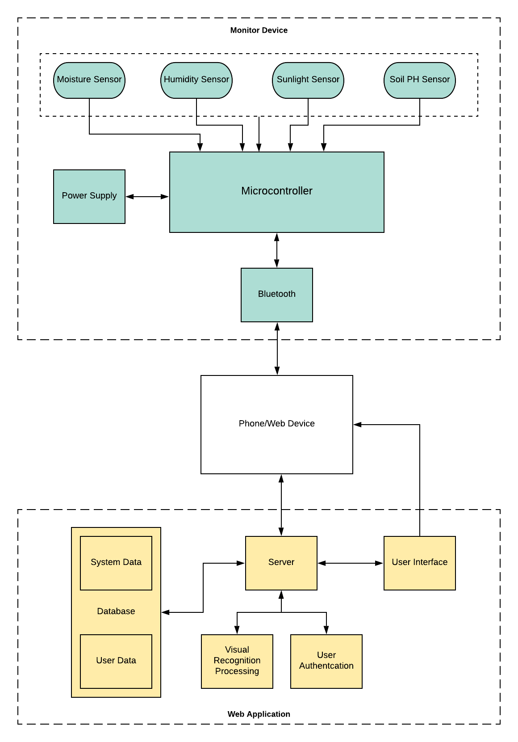

As shown in the block diagram, the Plant Doctor can be broken down into nine subsystems: the sensor system, visual recognition system, server system, database system, phone/web device system, power supply system, housing system, user authentication system, and the user interface. The central processing unit will draw power from the power supply subsystem, and will subsequently distribute power to the appropriate sensors.

The CPU uses one-way communication with the sensor subsystem, only receiving sensor measurements directly from the sensors. Once the CPU collects the sensor measurement data, it then wirelessly relays that data to a user’s phone application.

The phone application will request a photograph of the plant, once the user takes a photo of the plant the image will be sent to the Amazon cloud to be used by the machine learning model. After which, the microcontroller will begin transmitting sensor measurements to the application. After the data processing is complete, the results are displayed to the user interface. The user authentication subsystem will be used to create a user account that contains a collection of the house plant health data that each user contributes to the application. The user account will comprise of username, email, and password, and the information will be stored in the encrypted user data database. The application will remain logged into the user’s account until the user manually signs out.

Below is the electrical diagram detailing how our microcontroller, the ESP32 Wroom, is connected to our sensor and battery power subsystems. The microcontroller and each of the sensors are powered by a 3.7V LiPO battery whose voltage has been reduced to 3V by connecting a silicon diode in series with the battery to drop the voltage 0.7V. An ON/OFF switch was also added to the power supply system to allow the user to power down the device once they finished using it, in order to conserve battery power. The power supply is connected to the 3V3 pin and GND pins on the microcontroller. Below is a detailed description of each subsystem.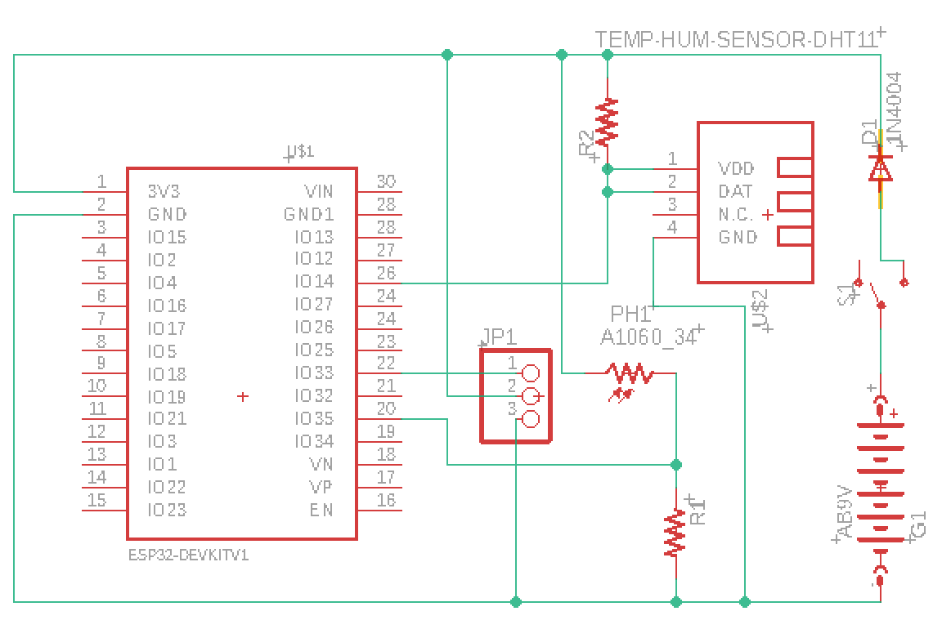

**Sensor system**

The sensors for this device were chosen based on their reliability and relatively low cost. Both analog and digital sensors were used in this project, which at first was challenging because we did not have any previous experience with the ESP32 Wroom. The ESP32 Wroom has 18 ADC pins that can also function as digital output pins. However, it took much trial and error and a lot of research to discover the correct layout of all of the sensors due to the fact that it has two different types of ADC channels, which caused a lot of issues with certain sensors, specifically the DHT11 temperature and humidity sensor. Below is the schematic for the sensor pinouts: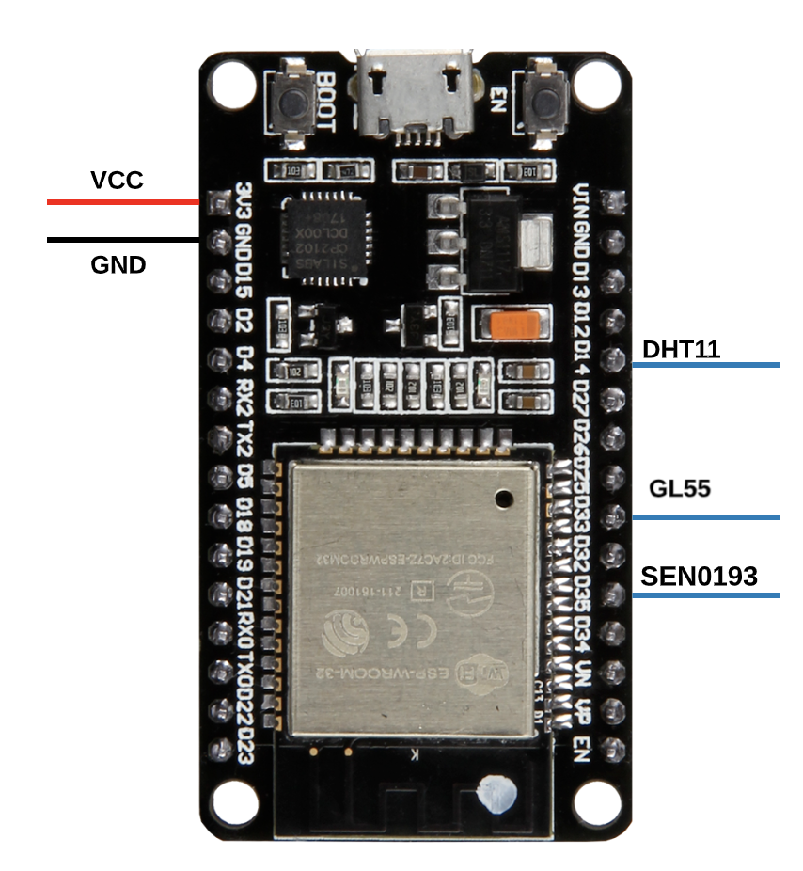

This layout was the basis for the design for the printed circuit board, which will be discussed in the hardware section.

**Power Supply system**

For the power supply system, many factors had to be taken into consideration. The battery would need to be able to handle current spikes as the ESP32 Wroom has a current pulse of 500 mA upon startup, while also supplying a certain voltage to the output pins and sensors. According to the ESP32 Wroom datasheet, the operating voltage for the microcontroller is between 2.3V and 3.6V, with the recommended power supply voltage being 3.3V. The ESP32 Wroom also has an onboard voltage regulator connected to the usb port and the VIN pin which can handle up to 5V. For our project, however, we wanted to avoid using larger battery power because we would need to reduce the voltage to 3.3V which would cause a lot of unwanted heat and could potentially be wasteful of the battery charge. Our solution was to use a 3.7V LiPo battery with a 1200 mAh capacity.

Since we wanted to avoid using the onboard voltage regulator, which would need a voltage supply of at least 5V, we chose to use the 3.7V battery connected in series with a silicon diode to drop the voltage to around 3V. In this way, we were able to connect the battery directly to the 3.3V input pin to power the device and all of the sensors. Furthermore, the reason we chose a silicon battery to drop the voltage 0.7V and not a germanium diode, which drops the voltage around 0.3V, is because when the LiPo batteries are fully charged, their supply voltage can range from 3.9 to 4.2V. When we initially measured the output voltage of our battery, it read about 3.9V when fully charged, therefore it was necessary to drop the voltage by 0.7V.

In order to conserve battery power, we also implemented an ON/OFF switch that is connected to the positive battery terminal. When the switch is flipped on, it creates a connection between the positive battery terminal and the rest of the circuit. When the switch is flipped off, it creates an open circuit, preventing any current from flowing throughout the circuit, therefore powering off the device.

Below is a table showing the power requirements for all of the sensors in the sensor subsystem:

|  |  |  |
| --- | --- | --- |
| Component | Operating Voltage (V) | Operating Current (A) |
| DHT11 Temperature and Humidity Sensor | 3-5 | 0.5mA to 2.5mA, standby is 100uA to 150uA |
| GL55 Photocell | Up to 100 | <1mA |
| SEN0193 Analog CapacitiveSoil Moisture Sensor | 3 - 5 | 5mA |
| ESP32 WROOM Hybrid WiFi and Bluetooth Chip | 3 | 500 mAh |

**CPU/Bluetooth system**

For the CPU, we used the ESP32 Wroom Dev Kit V1 microcontroller. There were several reasons why we chose to use this microcontroller for our project. First, and most importantly, it integrates a Bluetooth link controller and Bluetooth baseband to carry out baseband protocols and other low-level link routines, like modulation/demodulation, packet processing, bit stream processing, frequency hopping, etc. It also has internal SRAM which allows the microcontroller to transmit data at full speed. This was important for the project because it allowed us to transmit our sensor measurements to our phone application instantly and internally, without having to integrate an outside bluetooth sensor. The onboard bluetooth chip also made it extremely easy to connect our hardware with the phone application, as the bluetooth chip “advertises” itself and allowed us to simply search for available bluetooth devices via the smartphone interface, and connect.

Another reason why we chose this microcontroller is due to the multifunctionality of the output pins. More specifically, it has 18 ADC pins, 6 of which can read digital sensors. This made it simpler for us to connect both our analog and digital sensors to the micro. Below is a diagram of the output pins: 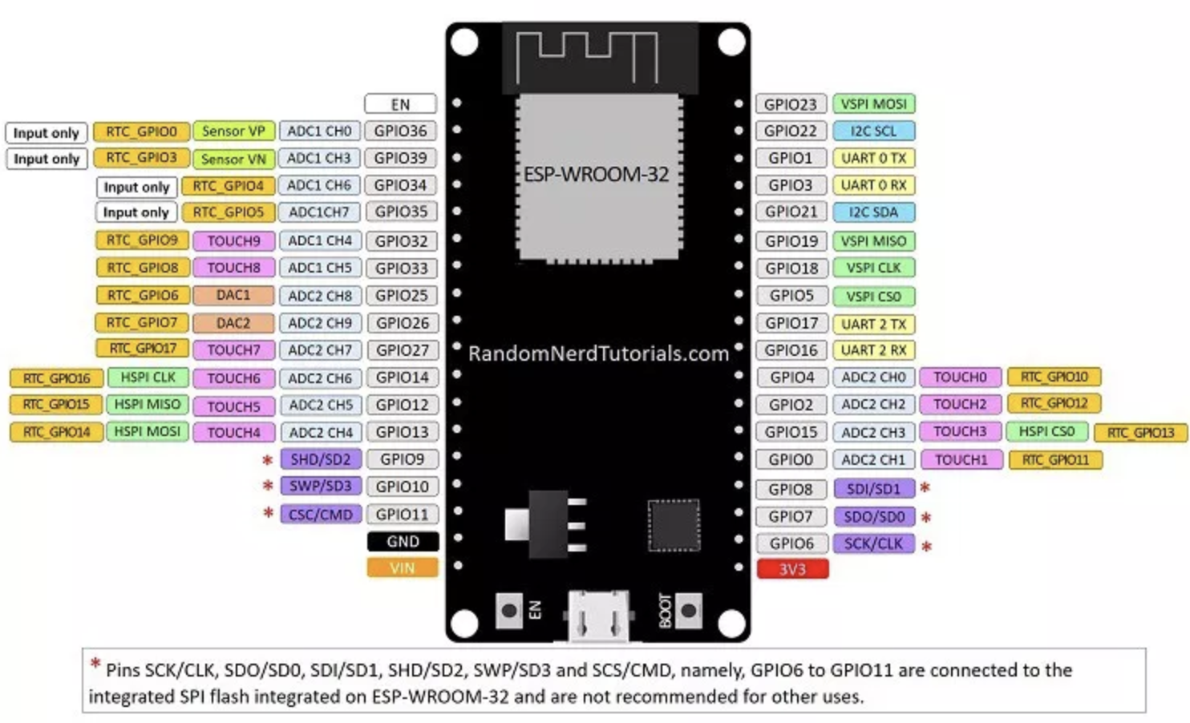

**Housing System**

The housing system was designed to house all the electrical components and allow them access to the outside for proper functionality. Due to time and budget constraints we decided to develop a casing using 3-D printing. The material used to print the case is sturdy and can handle everyday household use. The case was designed for easy access to the battery for future replacements/recharges.

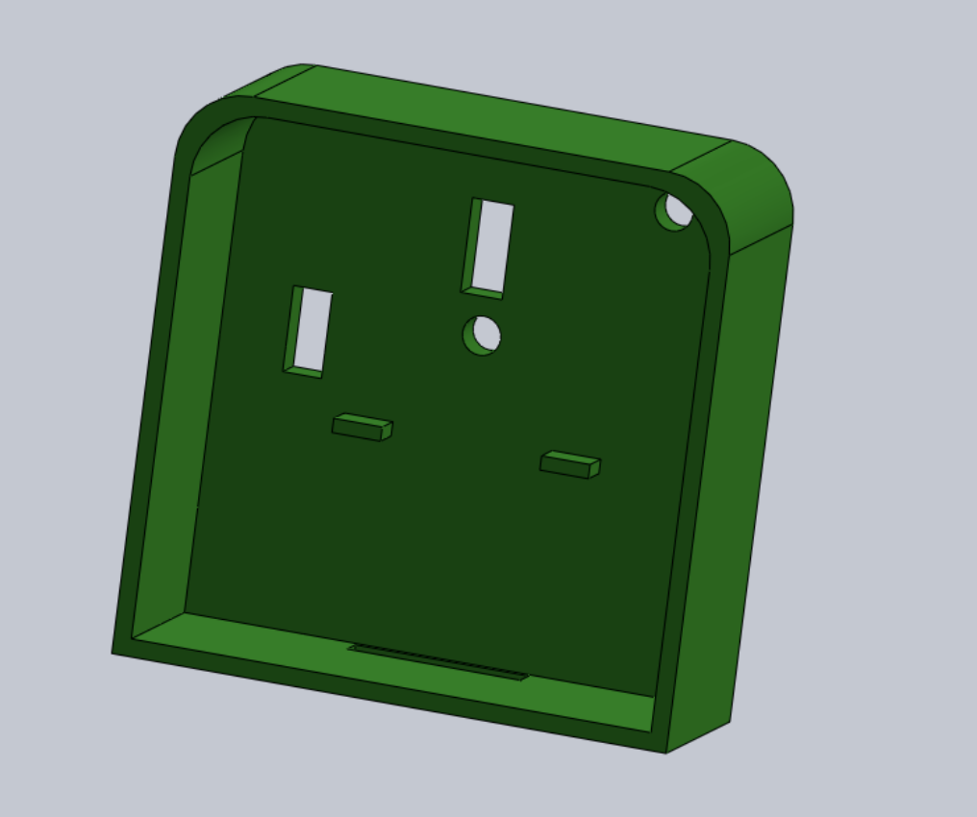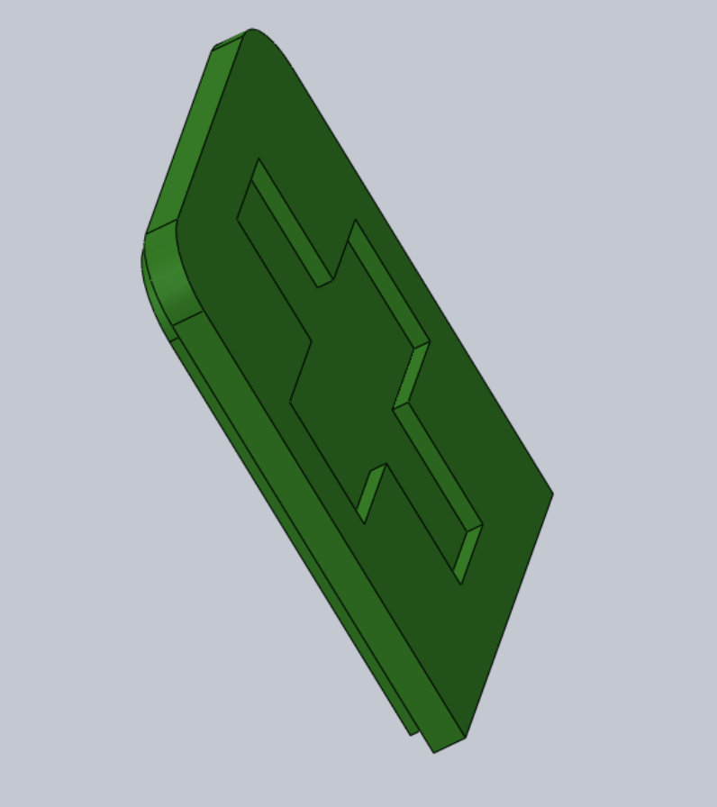

**User Interface System**

The user interface is designed to provide ease of access while also being appealing stylistically. It acts as the central access points for users to interact with the other subsystems. Users interact with the user authentication subsystem when first entering the app, and the bluetooth communication and machine learning subsystems when requesting for plant diagnostics vai the UI. The bluetooth sub-system is accessed via the API provided by Android. The user authentication and machine learning subsystems are accessed via the API calls and endpoints provided by Amazon.

**Machine Learning System**

The machine learning system is called via the API provided by Amazon and the endpoint set up on their servers. A custom Keras script was created to build the machine learning model, which makes a regression prediction from an image input. This model is a convolutional neural network and follows the following layer design:

x = inputs

x = Conv2D(16, (3, 3), padding="same")(x)

x = Activation("relu")(x)

x = BatchNormalization(axis=chanDim)(x)

x = MaxPooling2D(pool_size=(2, 2))(x)

x = Dropout(0.5)(x)

x = Conv2D(32, (3, 3), padding="same")(x)

x = Activation("relu")(x)

x = BatchNormalization(axis=chanDim)(x)

x = MaxPooling2D(pool_size=(2, 2))(x)

x = Dropout(0.5)(x)

x = Conv2D(64, (3, 3), padding="same")(x)

x = Activation("relu")(x)

x = BatchNormalization(axis=chanDim)(x)

x = MaxPooling2D(pool_size=(2, 2))(x)

x = Dropout(0.5)(x)

x = Flatten()(x)

x = Dense(16)(x)

x = Activation("relu")(x)

x = BatchNormalization(axis=chanDim)(x)

x = Dropout(0.5)(x)

x = Dense(4)(x)

x = Activation("relu")(x)

x = Dense(1, activation="linear")(x)

All training and system configurations were done via the services presented in the AWS console and the provided cloud-based jupyter notebook. A custom-made dataset of plant images and pH levels were uploaded to directories in the cloud for access by the model training process.

**User Authentication System**

The user authentication system is called via the API provided by Amazon. Code from the documentation was included in our Android application which pulls a pre-built, partially customizable authentication service for users to access. Successful logins are given a callback function to the main page of the app, so that only successfully validated users can access the app’s main functionality.

**Communication System**

The communication system consists of the bluetooth and wifi communication systems. The ESP32-WROOM has a bluetooth light energy (BLE) module which is used for it to act as a server that sends out its sensor data. The Android app requests reads from this server and through the Android API processes this data into local strings which can be displayed to the UI. The wifi portion of the system is completely managed by the Android BLU5 smartphone, and so no development or configurations were necessary on our part.

**Summary:**

Below is a summary table of each functional, user, and safety requirement. It details who was responsible for the subsystem, and how the requirement was met.

|  |  |  |  |
| --- | --- | --- | --- |
| Requirement | Subsystem | Description | Team Member Responsible |
| F.1 | Sensor System | The moisture sensor determines water content by measuring the conductivity of the soil. It was initially calibrated according to the manufacturer’s specifications, however it was fine tuned by subjecting the sensor to various moisture conditions so that it would be more precise for our specific project (i.e. varying degrees of soil moisture). | Rachel Vears |
| F.2 | Sensor System | The humidity sensor measures the levels of humidity by detecting electrical conductivity of the air, or by measuring the temperature of the air and comparing it to a sensor encased in dry nitrogen. This sensor comes already calibrated by the manufacturer, and the readings were compared to known values for verification. | Rachel Vears |
| F.3 | Sensor System | The light sensor measures the intensity of light shining on the area where the plant is located. This sensor did not need calibration, as the output from the sensor is a direct reflection of the brightness of light. In other words, the brighter the light, the higher the sensor reading in mV becomes. We were then able to format those values into something meaningful to the user. | Rachel Vears |
| F.4 | Sensor System | The soil pH sensor was not implemented as intended due to high inaccuracies with the measurements. Instead, we implemented a machine learning model that we custom built and trained on a custom data set to recognize soil pH via plant leaf color. | Rachel Vears/Jason Schilling |
| F.5 | Sensor System | The temperature sensor uses voltage to determine the ambient temperature in the air. This sensor was calibrated based on manufacturer specifications and compared to reliable temperature measurements in order to verify the accuracy of the sensor. | Rachel Vears |
| F.6 | Visual RecognitionSystem | This subsystem was supplied by Amazon cloud service which develops deep learning models. It is able to receive pictures and metric data to train itself on recognizing soil ph. It then only uses picture data to recognize soil pH. | Jason Schilling |
| F.7 | Server System | Due to time limitations, the server system was not implemented so as to insure we were able to develop the machine learning model. | Jason Schilling |
| F.8 | Visual RecognitionSystem | The image that users take of their plant will be sent to a cloud-based machine learning model. This model will predict the pH of the plant’s soil using this image. | Jason Schilling |
| U.1 | Phone/Web Device System | The sensor device communicates with the Android application via bluetooth light energy (BLE). With this communication, the application reads the values retrieved by the sensors on the physical device and presents them to the app UI. | Jason Schilling |
| U.2 | Power Supply System | The power for the system is supplied through a 3.7V 1200mAh Lithium Ion Polymer battery connected in series with a silicon diode to the 3.3V input pin of the microcontroller. | Rachel Vears |
| U.3 | Housing System | The housing system was developed using SolidWorks, and was 3D printed as a compact 80mmx80mmx35mm device. | Rachel Vears/Jason Schilling |
| U.4 | User Interface | The user interface shall supply the user with the processed output from the environment sensors. These requests include the predicted health status of the plant and a comparison of the retrieved sensor data to standardized data. In future iterations of the device, the user will be able to access a history of the plant’s health, as well as other plants they have in the application. However, due to time constraints we were not able to implement that aspect. | Jason Schilling/Rachel Vears |
| U.5 | User Authentication/User Interface | Amazon Cognito is used to present the user with a user authentication workflow (login, register, forget password) on the Android application. Users must login first before accessing the rest of the app. | Jason Schilling |
| S.1, S.2 | Housing System | The current prototype does not have sealant implemented throughout the casing, but future iterations of the case will be water resistant. | Rachel Vears/Jason Schilling |
| S.3 | Database System | The database was not implemented due to time constrains. | Jason Schilling |

## 

## **2.5** **State Diagram**

For our plant health monitor device, there are two main state diagrams showing the states and state transitions of the data processing and data collection procedures. An overview of the data collection and processing operations can be seen below. The initial state for the data collection and data processing procedure is Null, in which the sensor device is powered off and

the application is not requesting new metrics. When the device is powered on and the user requests measurement data through the application, the microprocessor begins collecting sensor data. After the microprocessor has collected the data, it is processed and then sent to the application to be displayed to the user. We were not able to implement the database functionality due to time constraints. We decided to allocate more time to the development of the machine learning model. Currently, there is no database to retrieve previous data, however future iterations will include a database.

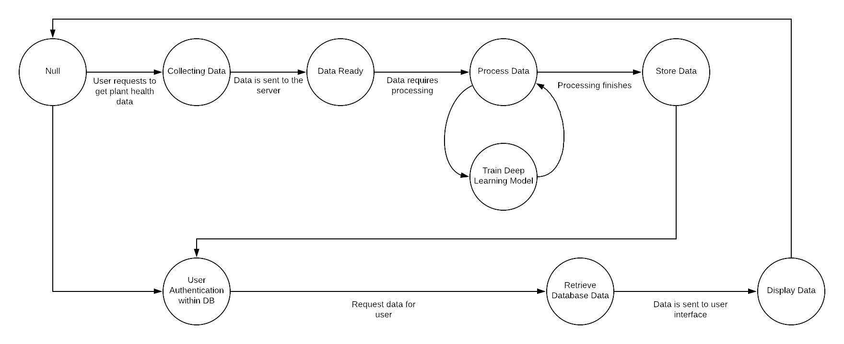 The next state diagram describes the data collection process via the microcontroller and sensors. The state of the device initially is the powered off mode, in which there are no sensors running and measuring data. When the user powers on the device, the microprocessor begins distributing power to the three sensors: moisture, sunlight, and humidity/temperature. Once the microcontroller is powered on, it waits for a command from the user application to start transmitting sensor readings. The command to begin reading the sensors is sent when the user takes a picture of the plant, which is then sent to the machine learning model. Once the micro receives the cue, the three sensors will take five measurements over a period of one second, at the end of which, the average of those five measurements is taken as the final reading for each sensor. After the final readings have been collected, the raw data is then processed by the microcontroller into an easily understood format. Once the data processing is complete, the data is then sent to the application to be displayed to the user.

# 

# 

# 

# 

# 

# 

# **3.** **System Implementation**

## **3.1** **Hardware**

The following table details the hardware used for the Plant Doctor System. The corresponding sub-system for each hardware component, as well as the testing and calibration procedures are provided in more detail below:

|  |  |
| --- | --- |
| **Nomenclature** | **Subsystem** |
| SEN0193 Analog Capacitive Soil Moisture Sensor | Sensor System |
| DHT11 Temperature and Humidity Sensor | Sensor System |
| GL5516 CdS PhotoCell | Sensor System |
| ESP32 WROOM Hybrid WiFi and Bluetooth Chip | Sensor System |
| 3-D Printed Housing | Housing System |
| Android Smartphone | Phone/Web Device System |
| 3.7 V 1200mAh LiPo battery | Power System |
| ESP32 WROOM Dev Kit V1 | All Systems |
| Printed Circuit Board | Sensor System |

**SEN0193 Analog Capacitive Soil Moisture Sensor**

**Team Member responsible for testing, calibrating, and integration: Rachel Vears**

The capacitive soil moisture sensor was connected to the ESP32 Wroom Dev Kit V1 via the GPIO35 (ADC1CH7) pin, it was also connected to VCC and GND nodes. It is important to point out that the manufacturer’s instructions to calibrate the datasheet were based on the sensor being connected to a microcontroller whose output pins were 10 bit resolution. Since the ESP32 Wroom analog pins have 12 bit resolution, the values we receive are on a range of 0 to 4095 for 0 to 3.3V power supply.

First, it was necessary to determine the sensor’s base air and water readings in order to begin the calibration process.To do this, the sensor was suspended in the air with nothing touching the capacitive sensor portion of the device, this gave a baseline for there not being any moisture detected by the sensor. The air value for the sensor was about 3507. To measure the sensor output for dry soil, the sensor was placed in a pot of soil that had been drying for a week, the output for dry soil was an average of about 3612 based on a series of four measurements. Next, the measurements for when the soil is not fully wet but not ready to be watered yet either were collected, the sensor was placed in a pot with moist soil, the readings gathered from that were an average of 2715 based on a series of four measurements. After that, the sensor reading for wet soil, or soil that had just been thoroughly watered was measured by placing the sensor in thoroughly watered soil.. The sensor output for wet soil was as about 2389 based on a series of four measurements. Lastly, the sensor was tested in pure water, it gave a reading of around 1675 mV.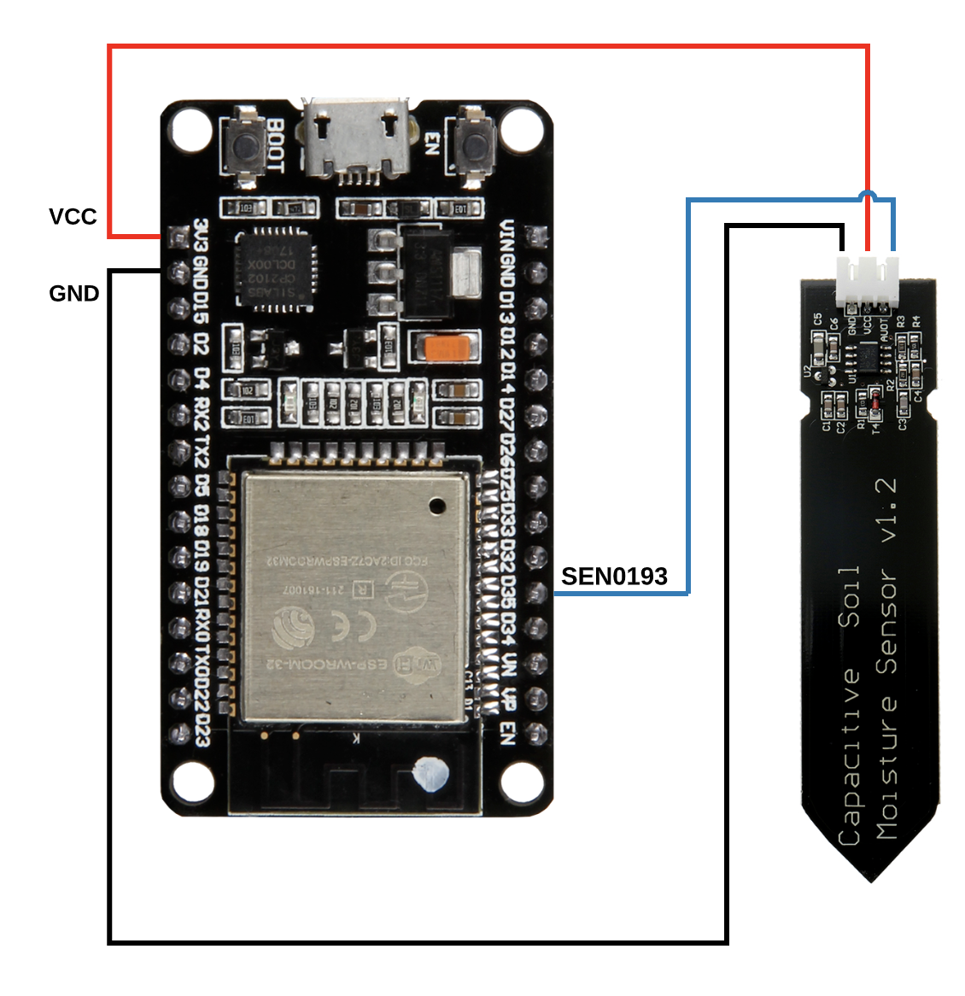

**DHT11 Temperature and Humidity Sensor**

**Team Member responsible for testing, calibrating, and integration: Rachel Vears**

The DHT11 temperature and humidity sensor is the only digital sensor that was used in the sensor system. To connect the DHT11 Humidity sensor to the microcontroller, the VCC pin was connected to the VCC line, the GND pin to the GND line, and the data output pin to pin D14 on the ESP32 Wroom. There was also a 10k ohm pull up resistor connected from the data output pin to the VCC pin. The diagram below details the way the sensor was connected to the microcontroller:

There were several factors that made working with this sensor extremely tricky, and there was quite a lot of research and trial and error involved to get the sensor working with the ESP32 wroom microcontroller. There are several reasons as to why we had such difficulty integrating the DHT11 into our device, but it mainly has to do with the way that the sensor sends data to the microcontroller. When the sensor is sending data, it pulls the dataline high for 70us (for a 1) or 26us (for a 0). See the diagram below (from the DHT11 datasheet).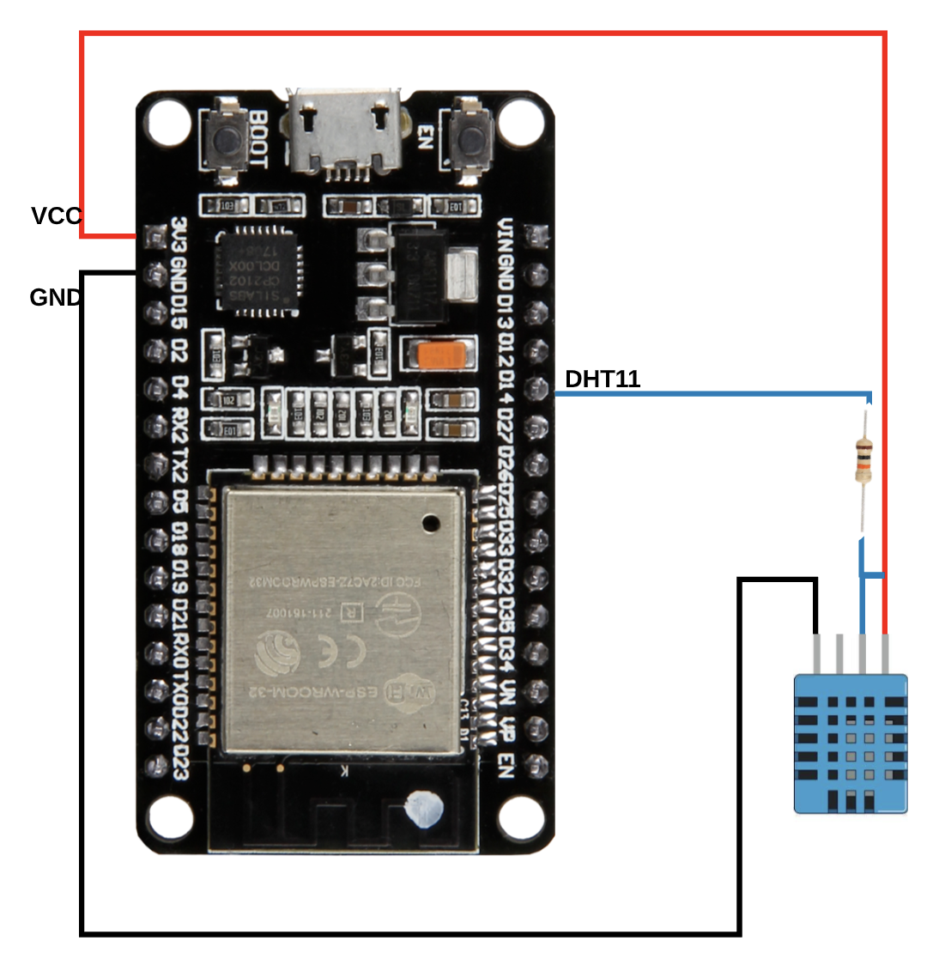

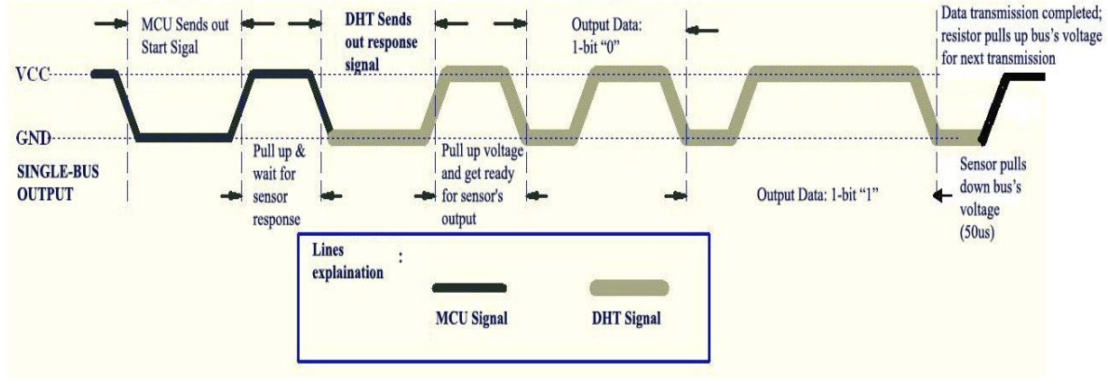

This means that during the data transmission, the ESP32 has to monitor the data line and measure the length of pulses from the sensor in order to determine if 1’s or 0’s are being sent. The main reason we were having so many issues getting the DHT11 to work with the ESP32 was because there are interrupts that can interfere with the time measurement of the data line pulses. Furthermore, there is a multi-task scheduler that can switch to a different task at any time while the sensor is transmitting data, which causes the time measurement to fail. These time measurement issues are complicated further by the use of the board’s BLE function, this is because the reading of the sensor will be continually interrupted by task switches while the BLE is in use.

In order to account for the ESP32 Wroom interrupts that were causing the sensor reading to fail, we had to install a special library called DHTesp, written by github user beegee-tokyo, that disables task switching of the real time operating system kernel for embedded systems, or FreeRTOS, on the ESP32 as long as data from the DHT11 sensor is being received. Furthermore, it is important to note that some digital sensors, in our case the DHT11, will not work with the ESP32 Wroom ADC channel 1 pins while BLE is being used. Thus, that is why our DHT11 sensor is connected to the ADC2 GPIO pin 14.

**GL5516 CdS PhotoCell**

**Team Member responsible for testing, calibrating, and integration: Rachel Vears**

The GL55 PhotoCell sensor was connected to the ESP32 Wroom as shown in the diagram below:

The highest reading the photoresistor will give is 1023 for a 10 bit resolution output pin when a light source is shining directly on top of the photoresistor. That is the highest analog value the sensor can read through a 10 bit ADC pin for a circuit being supplied 5 volts. However, since we were the ESP32 Wroom, which has a 12 bit resolution for ADC pins and is being supplied approximately 3V, the highest value the photocell will give is 4095. To verify the highest and lowest values being measured by the sensor, the photocell was placed directly under a bright light source. It gave a value of exactly 4095. To verify how low the photocell would go, we placed the sensor in total darkness, and received a reading of 0. We then displayed the photocell reading as percentage of light, with 0% being complete darkness and 100% being direct sunlight. 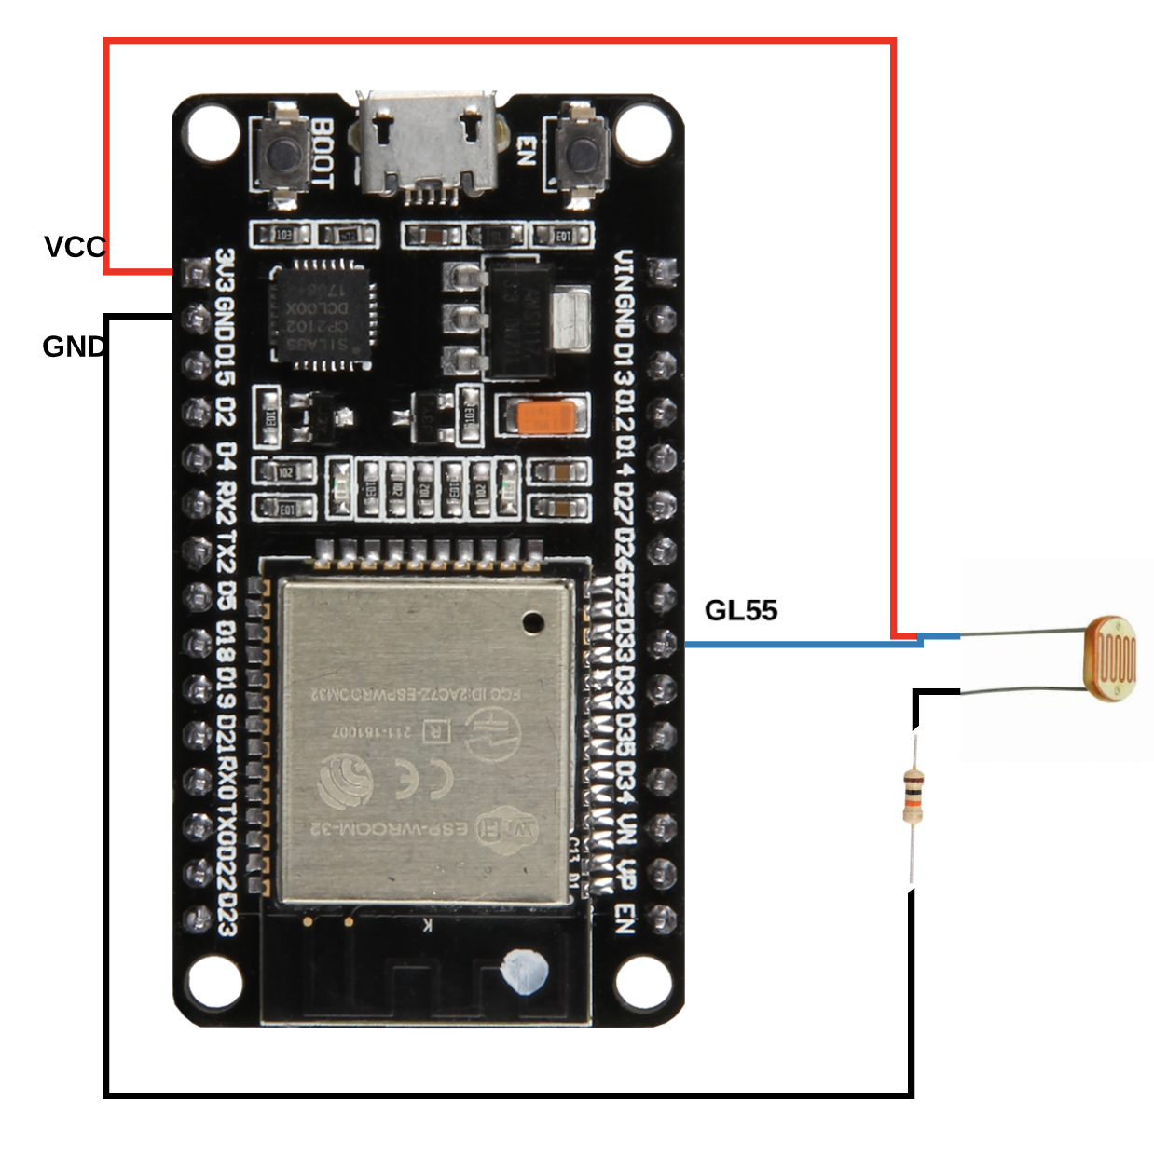

**Android Smartphone**

**Team Member responsible for testing, calibrating, and integration: Jason Schilling**

An Android BLU5 smartphone was used for the presentation of the user interface and wifi capabilities. The Android smartphone comes pre-tested and pre-configured, so testing these components was unnecessary, but the use of these services verified their functionality and performance. This device was integrated into our system via its Bluetooth and WiFi communication capabilities, which allow it to talk with the sensor device and the cloud-based services respectively.

**3-D Printed Housing**

**Team Member responsible for design: Jason Schilling**

**Team Member responsible for integration with hardware: Rachel Vears**

A 3-D printed housing was used to enclose the electrical components of our device, with holes for any components that needed access outside of it. Measurements were made for the electrical components and their placements based on the custom PCB. SolidWorks was used to create the 3-D casing specific to the retrieved measurements. Prints were made and the model design was revised several times according to how the components fit.

**3.7V 1200mAh LiPo Battery**

**Team member responsible for testing and integration: Rachel Vears**

We chose the 3.7V 1200mAh LiPo battery because it meets both the voltage supply requirements and peak current requirements for our microcontroller. According to the ESP32 Wroom datasheet, the operating voltage for the microcontroller is between 2.3V and 3.6V, with the recommended power supply voltage being 3.3V. Since we wanted to avoid using the onboard voltage regulator, which would need a voltage supply of at least 5V, we chose to use the 3.7V battery connected in series with a silicon diode to drop the voltage to around 3V. In this way, we were able to connect the battery directly to the 3.3V input pin to power the device and all of the sensors. Furthermore, the reason we chose a silicon battery to drop the voltage 0.7V and not a germanium diode, which drops the voltage around 0.3V, is because when the LiPo batteries are fully charged, their supply voltage can range from 3.9 to 4.2V. When we initially measured the output voltage of our battery, it read about 3.9V when fully charged, therefore it was necessary to drop the voltage by 0.7V.

**Printed Circuit Board**

**Team member responsible for development, testing, and integration: Rachel Vears**

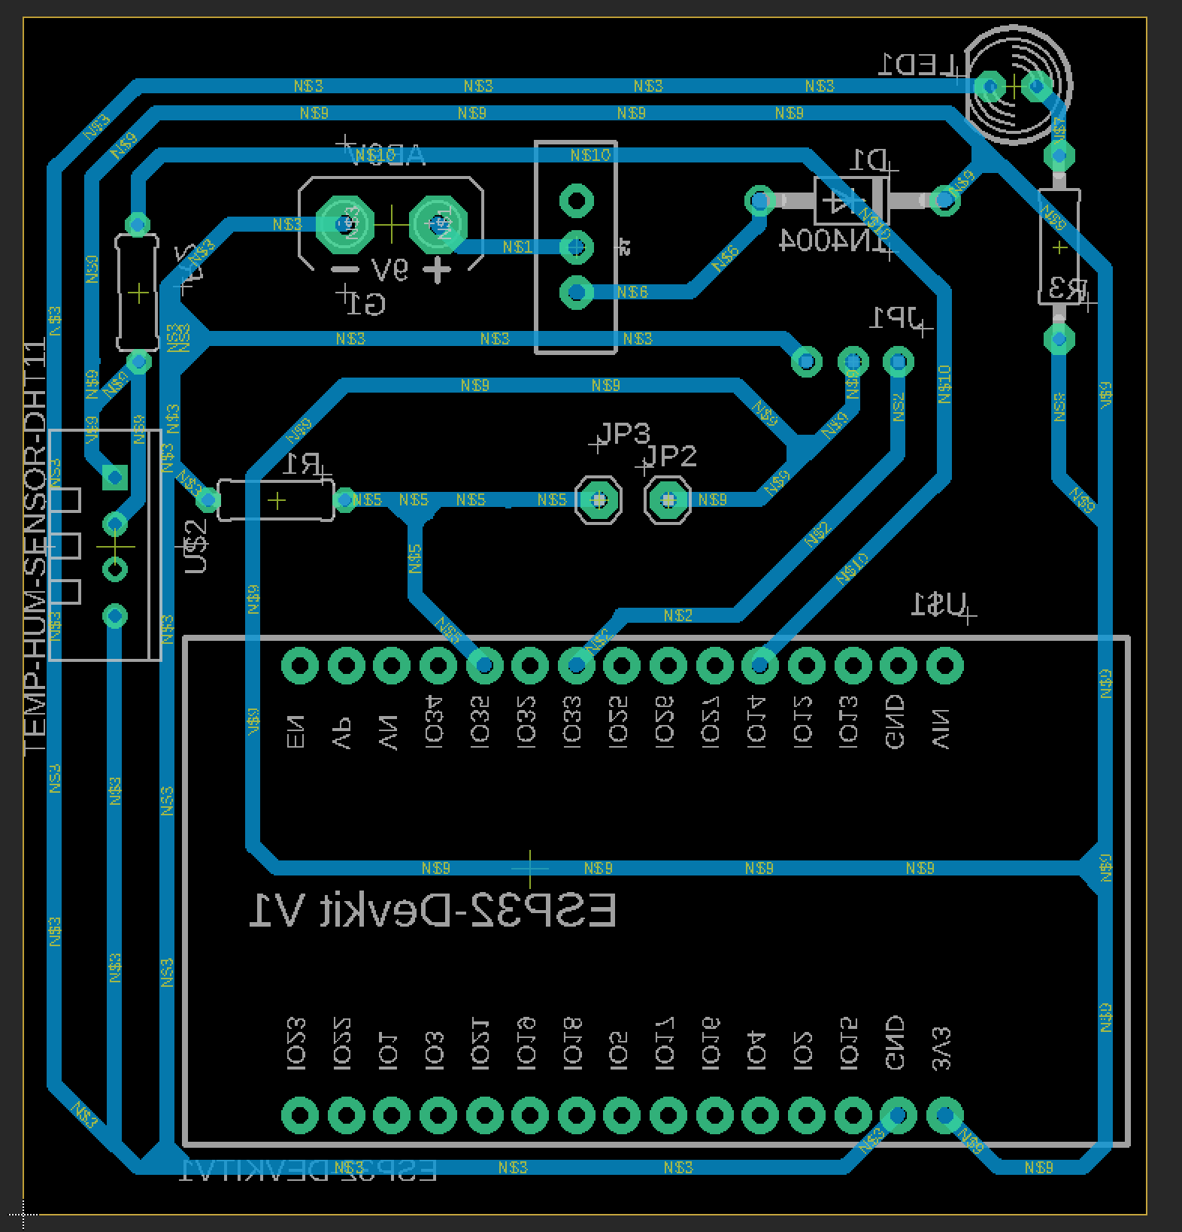

After the initial prototype board was developed and tested, it was important to design and integrate a printed circuit board in order to reduce the size of our device. The software Autodesk Eagle was used to design the final device’s printed circuit board. However, before developing the PCB it was necessary to find and download several custom libraries. The most important library was for the schematic for the ESP32 Wroom 32 Dev Kit V1 board, as autodesk did not have a library already installed to handle schematics with that part. Luckily, in the ESP32 data-sheet there was a link to a hardware resources webpage by espressif, from there we were able to download the schematic for the board. Next, it was necessary to find a library for the DHT11 humidity sensor. Luckily, a website called diymodules.org had the schematic and footprint for the DHT11 sensor. Lastly, we needed to find a schematic that would be suitable to use with the Capacitive Soil Moisture sensor. This however, did not have a library anywhere online. So as a workaround, we downloaded the adafruit library and installed it. That gave us access to a schematic and footprint for a 1 x 3 pin header that we were able to use to solder the three pins from the soil moisture sensor to the breadboard.

One thing to consider when downloading auxiliary schematics is that they are often times reversed. So it is very important to make sure that they are mirrored in order for the pins to be in the correct position once it is printed. We ran into this issue with our ESP32 Wroom schematic, so as a workaround the board was designed on the bottom layer instead of the top, so that when it was printed out, the pin locations would be mirrored.

## **3.2** **Software**

There will be several components and services used for the application. The smart phone application will be developed using Amazon’s Amplify framework, which simplified the integration with Amazon Cognito. The machine learning portion of our application will be processed by Amazon’s cloud service, SageMaker. The comparison of current environmental measurements to ideal environmental conditions would need to be created from scratch. While many pre-built solutions will be utilized, many portions of the application will need to be built from scratch, including connecting all the components and services, sending and receiving information from the UI, and sending requests to the right locations. The chart below summarizes the main components.

|  |  |
| --- | --- |
| **Purpose** | **Solution** |
| Machine Learning Cloud Service | Amazon SageMaker |
| User Authentication Service | Amazon Amplify Framework |
| Metric Comparison Service | Custom |
| Phone Camera Service | Android API |
| Bluetooth LE Service | Android API |

**Machine Learning Service**

**Team member responsible for development, testing, and integration: Jason Schilling**

The machine learning service was built using Amazon SageMaker. A cloud-based Python notebook that is used as the main source for training and deploying any models. A Keras script was developed to build the model, and is called by SageMaker’s API to build it and deploy it. Once deployed, the model can be given an image (in the correct format) and return a prediction of that image’s pH level through the SageMaker API methods. This requires interfacing with the camera service to retrieve a photo and the user interface to display the prediction. OpenCV is used to process the image and convert it into the correct format for the model.

**User Authentication Service**

**Team member responsible for development, testing, and integration: Jason Schilling**

The user authentication service was built using Amazon Cognito. Amazon provides this service as an individual entity, but it is recommended (by peers) to use the Amazon Amplify framework which can be used to integrate Cognito more easily, which was done for this project. The user is presented with a pre-configured (by Amazon) login screen that handles new registration, login issues, and successful logins which then direct the user to the main page of the app. The user database can be accessed via Amazon’s web portal, which present admin functionality through the UI.

**Metric Comparison Service**

**Team member responsible for development, testing, and integration: Jason Schilling**

The metric comparison service was implemented to its minimum form due to time constraints. The ideal service would query a database with predefined ideal plant environment metrics, but our practical service instead uses hard-coded values for the comparison. The values were retrieved from online sources and are specifically for fiddle leaf fig.

**Phone Camera Service**

**Team member responsible for development, testing, and integration: Jason Schilling**

The Android API provides methods to access the on-board camera of the device. Our software calls the pre-built camera activity once the user clicks a button. This activity is non-customizable, but serves the requirements of this project. There is an activity callback function which takes the captured image and processes it for the machine learning component.

**Bluetooth LE Service**

**Team members responsible for development, testing, and integration: Jason Schilling and Rachel Vears**

The Android API provides methods to access the bluetooth light energy functionality of the device. Our software automatically searches for the UUID of the sensor device and connects to it, and then retrieves the sensor data once that process is called. This data is only sent when requested, so the battery consumption for operating the bluetooth is reduced. The requests ask the sensor device for data, which triggers a read command on that data. Read commands are asynchronous, so a command queue is created to organize them. The sensor device broadcasts when the data has been read and is ready, which is then intercepted by the Android device. This data is then channeled to the correct location in the user interface according to its source.

**Building the Custom Dataset**

**Team member responsible for data collection: Rachel Vears**

**Team member responsible for integration with machine learning model: Jason Schilling**

In order to train our custom machine learning model, since there is no dataset in existence that correlates plant images with soil pH, it was necessary to build our own data set of pictures of the plants we were using and documenting the correlating environmental and pH conditions to be uploaded to the model.

As we are using a machine learning model to detect the plant’s soil pH based on a picture. It was important to have a decent range of soil pH to study and use for the dataset, in this way it will be more accurate. Because of this, we decided to use four plants, with pH’s of 5.0, 6.0, 7.0, and 8.0, all with ideal environmental conditions (i.e their soil moisture, light, temp, etc conditions will all be ideal for the plant). This gives us a good range to study the visual effects of soil pH.

With respect to the other environmental conditions, we decided to experiment with only two (seeing as we do not have enough plants to do more than that). We chose soil moisture levels, and light levels, as our other environmental conditions to be accounted for with the machine learning photo recognition. This is because the soil moisture and light levels have a greater effect on the appearance of the plant than do temperature and humidity. Thus, we felt those two conditions to be the most important to account for when building our machine learning model.

Additionally, it is important to note that we used the plant with the pH of 7.0 as the control plant, as all of its other environmental conditions will be ideal and the pH of 7.0 is ideal for this species of plant.

In order to measure pH accurately, we had to develop a method to consistently read the pH of each of the plants. In order to make the soil PH measurements as consistent as possible we did extensive research into the topic and came across a paper in the University of Florida IFAS Extension Website. The paper, written by E. A. Hanlon, Jr., was titled Soil pH and Electrical Conductivity: A County Extension Soil Laboratory Manual. The procedure for measuring the plants soil pH is time consuming, however we found it necessary to use a verified method to ensure accuracy. The following is the procedure for measuring soil pH:

The soil should first be air dried for at least two hours and passed through a 2-mm sieve before scooping into measurement containers (in my case plastic cups). Next, a 25g scoop of soil should be combined with 40mL of fresh, distilled water, giving a 2:1 water-to-soil ratio. After mixing the soil and water mixture, it is recommended to let it sit for approximately 30 minutes before measuring the pH. Upon measuring the pH, the sample should be stirred once more and then immediately measured. After the pH for a soil sample is taken, it is then thoroughly rinsed with distilled water before being used to measure the next sample. It is also important to note that the pH of the water is measured before it is mixed with the soil for accuracy.

The measurements taken from this procedure were recorded in an excel sheet that documents the Plant ID (#1-8), Picture ID (we are giving each photograph of the plant an ID to help better associate images with raw data), pH reading, Moisture Levels, Light levels, and Temperature. Additionally, the initial pH of each plant is being recorded before we adjust the pH for testing purposes. Below are examples of plant images and the excel sheet storing the information for each image:

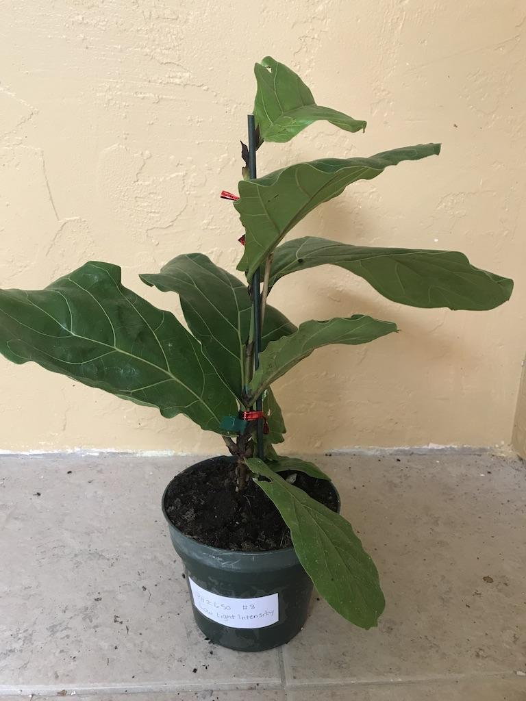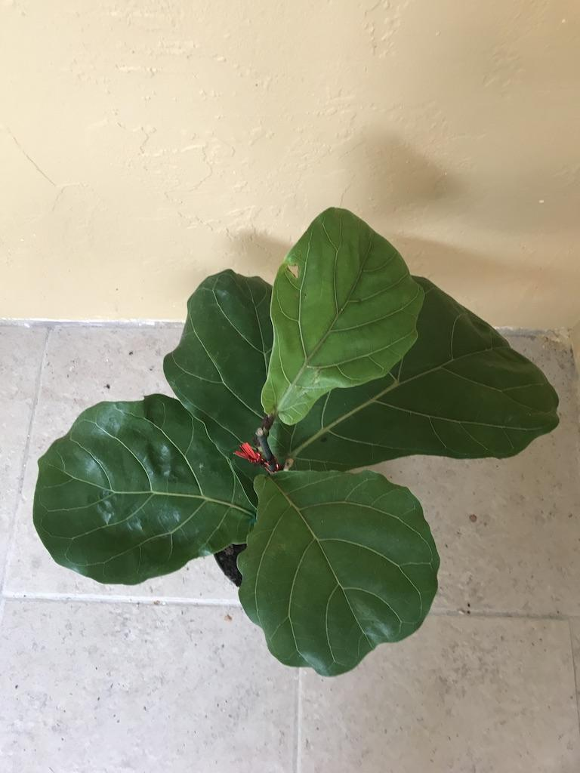

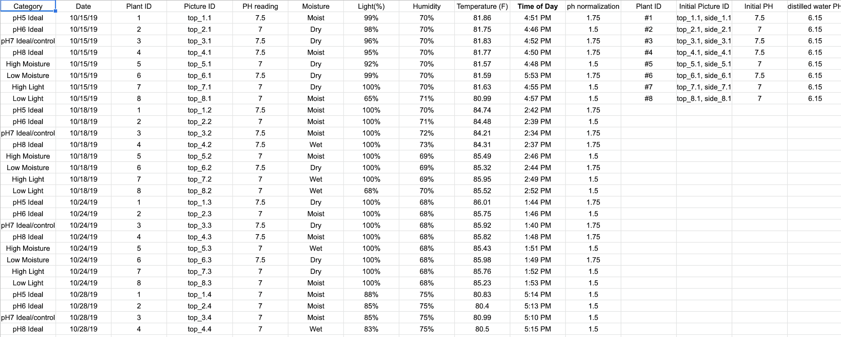

**3.3** **User Interface**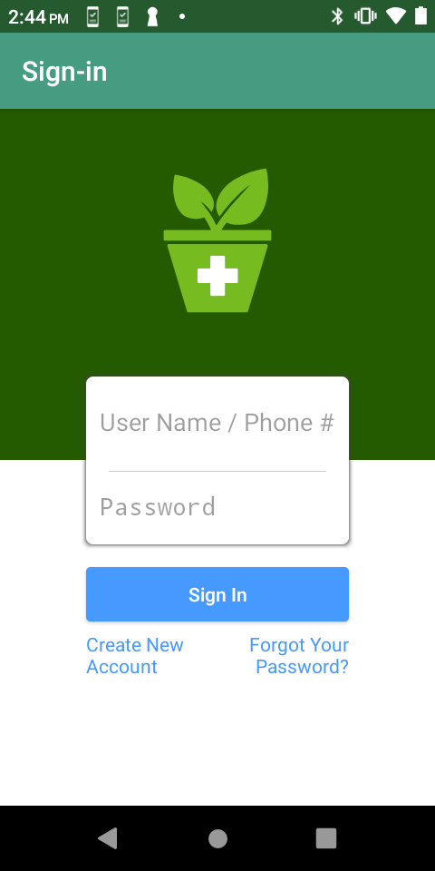

The first screen users see when accessing the Android application is the authentication screen. From this screen users can register an account, reset their password, or login to the application. This authentication functionality is provided by Amazon, and will present specific messages for any validation errors that occur during the authentication process.

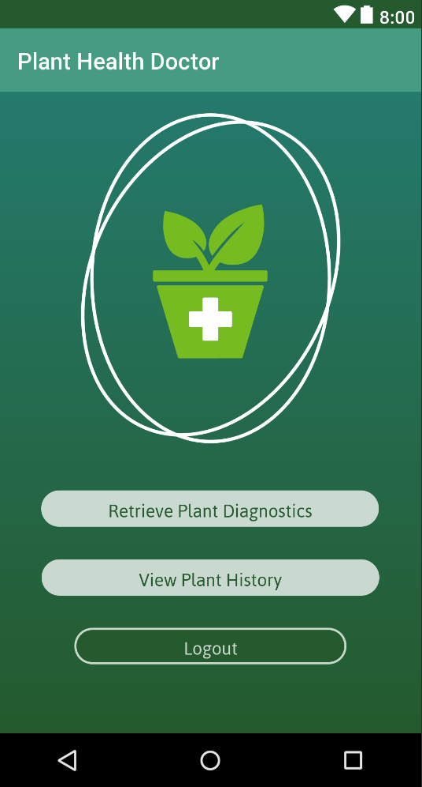

After logging in, the user is presented with the “main face” of the application. From this point, users can retrieve plant diagnostics and logout. In future iterations users would be able to pull up historical data about each of their plants they have taken metrics for. Users are taken to a camera when they click “retrieve plant diagnostics” where they take a picture of the plant they want metrics for.

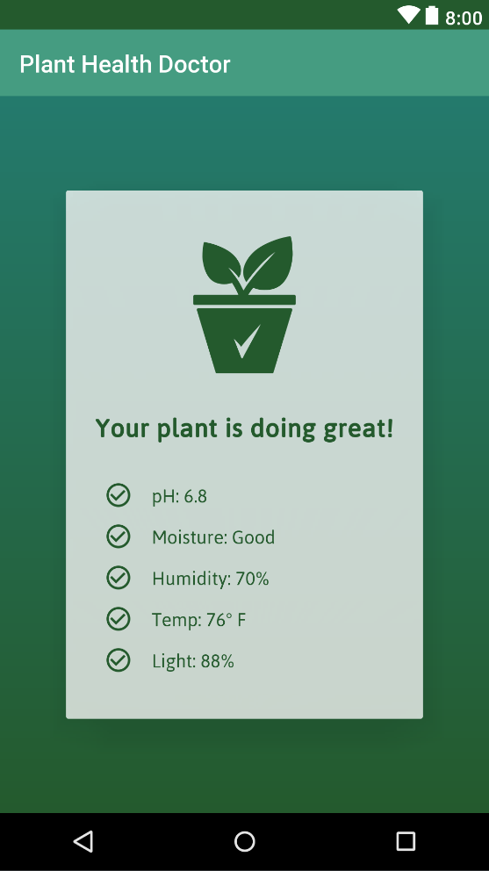

Once all the metric data has been collected the app presents the results of the comparison between those retrieved metrics and the ideal metrics stored in the app. If conditions are ideal, a green check mark and green text is presented for that metrics. If conditions are not ideal, then the check mark and text are red. Users can click on each metric to open up a popup that describes the requirements of the plant for that specific metric.

## **3.4** **Data Communications**

Our device uses bluetooth for its sensor data communication and WiFi for its user authentication and machine learning prediction communication.

Our device uses the bluetooth capabilities of the ESP32 WROOM Hybrid WiFi and Bluetooth chip and an Android phone for communication. The sensor device constantly posts the sensor data its retrieving. The Android phone then searches for the sensor device via its UUID, discovers all the characteristics associated with it, and requests to read each characteristic. This data is then stored as a string in the application and is presented in the user interface.

WiFi communication is achieved using the built-in WiFi capability of the Android phone. The first use of this communication methods is for user authentication. The credentials the users provide is authenticated against the valid user credentials stored in the Amazon Cognito cloud database. Each user’s login credentials is stored in this database, and other info about their account (such as email, name, etc.) is stored as well.

The other component that uses wifi communication is the machine learning pH prediction service. The machine learning model is stored in the cloud via Amazon SageMaker. Prediction requests are sent to this service and it returns a prediction value which is stored in a string and presented to the user interface.

# 

# **4.** **Testing and Performance Evaluation**

**Machine Learning Model Testing Procedure**

The mean absolute error (MAE) was used as a loss function for the training of the pH prediction model. This measurement takes the average magnitude of the errors in a set of predictions, and the model tries to minimize this. The variance is also calculated to make sure the model isn’t overfitting on the mean.

**User Authentication Testing Procedure**

The user authentication was tested by simulating the implemented workflows (registration, login, and forgot password). Fake users were registered and used to login and reset their passwords. Invalid credentials were entered into the login procedure to verify its functionality.

**User Interface Testing Procedure**

The user interface was tested by going through the application and attempting many finger commands on the UI. All buttons presented were pressed and the navigation between all the activities was verified.

**Sensor System Testing Procedure**

Once the sensors were integrated with the final device PCB, it was necessary to do a test run to ensure that all of the sensors were functioning as they should be. To do this, the device was assembled. The sensors were soldered to the PCB. After which, it was a matter of running the sensors through a series of conditions to make sure they were reaching their previously determined values. In other words, the moisture sensor was tested by running it through a set of tests, placing the sensor in water, reading the value while it was suspended in the air, placing the sensor in dry soil, and in moist soil. The readings from the sensor remained as they were before integration with the PCB. The same was done for the light sensor, and the DHT11 sensor. Therefore, since the sensors were behaving the same after integration with the printed circuit board, we determined that the test was successful and the sensor system was operating as it should be.

**Bluetooth System Testing Procedure**

To test that the onboard bluetooth chip was still communicating with the android application after it had been integrated with the PCB, we powered the PCB and placed the device under conditions to which all of the sensors would be receiving specific input. Furthermore, the android application was programmed to automatically connect with the ESP32 bluetooth chip as soon as it is powered on. So, when we powered on the ESP32, it automatically connected to the android application. That was the first step in verifying that the bluetooth system was working in the final device. The second step was to verify that the sensor readings were still being transmitted via bluetooth. We verified this functionality by sending a request via the android application to the ESP32 Wroom to begin collecting sensor data. Once the ESP32 Wroom collected the sensor data, it would display the measurements to the user interface. This test was successful, as all sensor values were being displayed correctly in real time.

**Power System Testing Procedure**

Before integrating the battery power supply with the printed circuit board, we tested its functionality on the prototype breadboard. Both the ON/OFF switch and the 3.7V LiPo battery were connected to the prototype board in the same manner as shown in the electrical diagram. After the two components were connected, a digital multimeter was used to verify the voltage through the device. The initial battery voltage for the fully charged 3.7V LiPo battery was 3.9V. We then measured the voltage after it was dropped by the resistor, which gave us a 3.2V entering the ESP32 Wroom 3.3V input pin. Next, the voltage was measured at each sensor location to make sure that the correct voltage was being supplied by the battery. Indeed, throughout the prototype board, a voltage of 3.2V was being supplied to all devices.

After integrating the ESP32 Wroom and the sensors with the PCB, it was essential to verify the battery power supply within the final device circuit. The battery was then integrated into the PCB, and with a digital multimeter, we measured the voltages at the 3.3V input pin and all of the sensors. The voltage was measured at 3.2V throughout the circuit, therefore it was determined that the final device power supply had passed the testing procedure.

## **4.1** **Performance Assessment**

**Machine Learning Model**

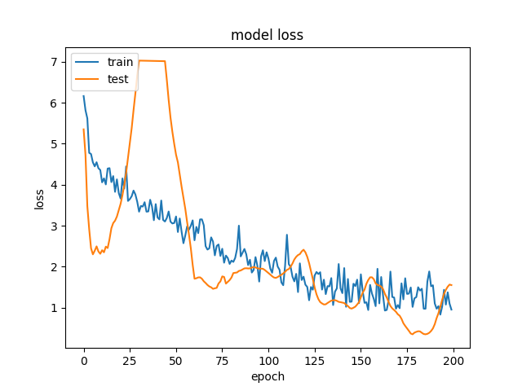

The training was able to reduce the model’s MAE to < 1, but the variance of the model was also very low, which indicates the model is overfitting on the mean of the data. This was verified by running the application and always getting a prediction value very close to the mean of the test data predictions, even when the image changes drastically.

The overall performance of the Plant Doctor system meets or exceeds our initial expectations. The device itself is compact, light, and portable. The environmental sensor system reads the environment accurately and within the specified time limits. The application is the central control unit for the system, connecting to the hardware device automatically, telling the microcontroller when to begin transmitting data, prompting the user to take photographs of the plant which can be sent to the machine learning model to predict pH. Functionally, the device works wonderfully. The only aspect that still needs to be improved is the accuracy of the machine learning model. For that, we need an extremely large dataset, of at least a thousand images. As such, due to time constraints we were not able to build the data set needed to accurately predict pH. Otherwise, the Plant Doctor system performs to our expectations.

# **5.** **Budget**

The following are the total expenses for the entire project, including parts that were ultimately not used, extra parts, the software used to build the machine learning model, and the plants used to build the data set

|  |  |  |  |  |
| --- | --- | --- | --- | --- |
| **Sensor** | **Description** | **Cost** | **Quantity** | **Total** |
| SEN0193 | Gravity: Analog Capacitive Soil Moisture Sensor- Corrosion Resistant | $5.90 | 2 | $11.80 |
| HPP801A031 | Analog Relative Humidity Sensor | $5.70 | 2 | $11.40 |
| DHT11 | Temperature and Humidity Sensor | $0.73 | 1 | $0.73 |
| MCP9700 | Low-Power Linear Active Thermistor IC | $0.29 | 2 | $0.57 |
| GL5516 | CdS PhotoCell | $0.95 | 2 | $1.90 |
| GRV-pH | Gravity Analog PH Sensor Meter | $24.99 | 1 | $24.99 |
| ENV-40-M-pH | Mini PH Probe | $52.00 +$11.41 | 1 | $63.41 |
| 9V Battery (2 pack) | 9V Battery | $6.46 | 1 | $6.46 |
| ESP32 Wroom Devkit V1 | 2 Pack ESP32 Wroom Devkit V1 | $14.02 | 1 | $14.02 |
| 9V Battery Connector (2 pack) | Power System | $2.98 | 1 | $2.98 |
| 6A125VAC | 6A125VAC Mini 3 Pin Toggle Switch | $0.46 | 1 | $0.46 |
| Fiddle Leaf Fig Plant | Plant used for training deep network | $19.50 | 8 | $292.50 |
| AWS Cloud Services | Cloud Database, Deployment, Deep Learning Network, User Authentication | Free | 1 | $137.67 |
|  |  |  |  | Total = $568.89 |

**6.** **Project Management and Workload Distribution**

Since our team was comprised of two members, a Computer Science major and a Computer Engineering major, we organized the workload into software and hardware responsibilities with overlap as needed. Jason Schilling was responsible for developing and implementing a custom machine learning model, developing the application functionality and UI, implementing user authentication, and designing the 3D printed enclosure. Rachel Vears was responsible for developing the initial hardware prototype; programming, testing, and calibrating the sensors and power supply system; designing the printed circuit board; integrating the sensors with printed circuit board; integrating the hardware with the 3D printed case; as well as manually taking soil pH measurements and building the machine learning dataset.

The overlap between the two responsibilities occurred mostly with hardware troubleshooting and implementing the bluetooth communication between the sensors and the mobile application. Below is a more detailed list of the responsibilities for each team member:

|  |  |  |
| --- | --- | --- |
| **System** | **Task** | **Responsible** |
| Sensor System | Build Working Prototype to collect metrics for computer model. | Rachel Vears |
| Phone System, User Authentication System, Visual Recognition System,  User Interface | Develop prototype application to display plant health information. | Jason Schilling |
| Develop method to retrieve sensor data for mobile application. | Develop method to retrieve sensor data for mobile application. | Jason Schilling/Rachel Vears |
| Sensor System | Design PCB for final plant monitor | Rachel Vears |
| Visual Recognition System | Compile plant health image + sensor metrics dataset. | Jason Schilling |
| Sensor System + Housing System | Design schematic for Final Plant monitor device detailing sensor locations, size, 3-d printed casing | Jason Schilling/Rachel Vears |
| Sensor System | Calibrate Final device sensors | Rachel Vears |
| Sensor System | Integrate microprocessor and sensors with PCB | Rachel Vears |
| Visual Recognition System | Train computer model to recognize plant health status via picture. | Jason Schilling |
| Housing System | Design 3-d Printed casing for device | Jason Schilling |
| Power Supply System | Develop Power Source for final device | Rachel Vears |
| Sensor System | Interface bluetooth/mobile data transfer with Final device | Rachel Vears/Jason Schilling |
| Phone System, User Authentication System, Visual Recognition System,  User Interface | Finalize application to display plant health information. | Jason Schilling |
| All Systems | Finish Assembling Final device to compile all sensor data. | Rachel Vears/Jason Schilling |

Below is an overview of the workload breakdown between the two members:

|  |  |
| --- | --- |
| Name | Effort |
| Rachel Vears | 50% |
| Jason Schilling | 50% |
| Total | 100% |

**7.** **References**

Shan, X. (2018). *CA2752594C*. Retrieved from <https://patents.google.com/patent/CA2752594C/en>

Lee, Y. M. (2009). *US20090025287A1*. Retrieved from <https://patents.google.com/patent/US20090025287A1/en?oq=US20090025287A>

김태완, 이훈형, 김지수, 김세한, 박현, 은지숙. (2018). *KR101830056B1*. Retrieved from <https://patents.google.com/patent/KR101830056B1/en?oq=KR101830056B1>

Oliver, I., Ecob, S. (2014). *AU2014101143A4*. Retrieved from <https://patents.google.com/patent/AU2014101143A4/en?oq=AU2014101143A4>

MCP9700 Low-Power Linear Active Thermistor ICs

<http://ww1.microchip.com/downloads/en/DeviceDoc/20001942G.pdf>

Gravity: Analog Capacitive Soil Moisture Sensor- Corrosion Resistant

<https://wiki.dfrobot.com/Capacitive_Soil_Moisture_Sensor_SKU_SEN0193>

HS1101LF Relative Humidity Sensor SPECIFICATIONS. (n.d.). Retrieved from

<https://www.mouser.com/datasheet/2/418/NG_DS_HPC052_J_A-1130038.pdf>

‌

Mini Photocell SEN-09088

<https://www.sparkfun.com/products/9088>

Android API Documentation

<https://developer.android.com/reference>

House Image Price Prediction

<https://towardsdatascience.com/predicting-house-prices-with-linear-regression-machine-learning-from-scratch-part-ii-47a0238aeac1>

Amazon Cognito Documentation

<https://docs.aws.amazon.com/cognito/latest/developerguide/cognito-user-identity-pools.html>

Amazon SageMaker Documentation

<https://docs.aws.amazon.com/sagemaker/index.html>

Keras Documentation

<https://keras.io/>

AtlasScientific Gravity Analog PH Sensor Meter

<https://www.atlas-scientific.com/product_pages/gravity/gravity_ph.html>

AtlasScientific Mini PH Probe

<https://www.atlas-scientific.com/product_pages/probes/mini_ph_probe.html>

Bluno Nano Arduino with Bluetooth 4.0

<https://wiki.dfrobot.com/Bluno_Nano_SKU_DFR0296>

DHT11 Temperature and Humidity Sensor

<https://www.mouser.com/datasheet/2/758/DHT11-Technical-Data-Sheet-Translated-Version-1143054.pdf>

ESP32 Pinout Reference: Which GPIO pins should you use? | Random Nerd Tutorials. (2019,

October 2). Retrieved December 7, 2019, from Random Nerd Tutorials website: <https://randomnerdtutorials.com/esp32-pinout-reference-gpios/>

ESP32 Wroom Datasheet

<https://www.espressif.com/sites/default/files/documentation/esp32_datasheet_en.pdf>

adafruit. (2015, December 7). adafruit/Adafruit-Eagle-Library. Retrieved December 7, 2019, from GitHub website: <https://github.com/adafruit/Adafruit-Eagle-Library>

webmaster@diymodules.org. (2017). DIYmodules.org. Retrieved December 7, 2019, from

Diymodules.org website:

[https://www.diymodules.org/eagle-show-object?type=dm&file=diy-modules.lbr&device=T](https://www.diymodules.org/eagle-show-object?type=dm&file=diy-modules.lbr&device=TEMP-HUM-SENSOR-DHT11)

[EMP-HUM-SENSOR-DHT11](https://www.diymodules.org/eagle-show-object?type=dm&file=diy-modules.lbr&device=TEMP-HUM-SENSOR-DHT11)

ESP32 DHT11 – Bernd’s development stuff. (2018, January 30). Retrieved December 7, 2019,

from Giesecke.tk website: <https://desire.giesecke.tk/index.php/2018/01/30/esp32-dht11/>

Instructables. (2017, December 19). ESP32 BLE + Android + Arduino IDE = AWESOME.

Retrieved December 7, 2019, from Instructables website:

<https://www.instructables.com/id/ESP32-BLE-Android-App-Arduino-IDE-AWESOME/>

Analog to Digital Converter — ESP-IDF Programming Guide v4.1-dev-1066-g93a8603c5

documentation. (2018). Retrieved December 7, 2019, from Espressif.com website:

<https://docs.espressif.com/projects/esp-idf/en/latest/api-reference/peripherals/adc.html>

‌E. A. Hanlon, Jr. (2015). CIR1081/SS118: Soil pH and Electrical Conductivity: A County

Extension Soil Laboratory Manual. Retrieved December 7, 2019, from Ufl.edu website:

<https://edis.ifas.ufl.edu/ss118>

How to Change the Soil’s pH in Potted Houseplants. (2012). Retrieved December 7, 2019, from

Sfgate.com website:

<https://homeguides.sfgate.com/change-soils-ph-potted-houseplants-35807.html>

Islam, M. A., Milham, P. J., Dowling, P. M., Jacobs, B. C., & Garden, D. L. (2004). Improved

Procedures for Adjusting Soil pH for Pot Experiments. Communications in Soil Science

and Plant Analysis, 35(1–2), 25–37.<https://doi.org/10.1081/css-120027632>

Adafruit. (2019, November 2). DHT sensor library. Retrieved December 7, 2019, from

Arduinolibraries.info website: <https://www.arduinolibraries.info/libraries/dht-sensor-library>

‌

‌

‌

‌

‌